CREATE DATABASE amazon;

USE amazon;

#1. Show all records from the dataset.
SELECT * FROM amazon;
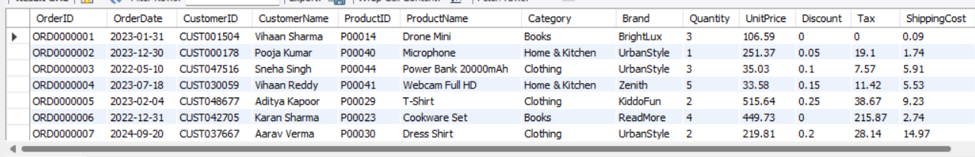
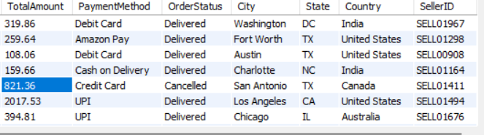

#2. Display only product names and prices.
SELECT ProductName, UnitPrice FROM amazon;
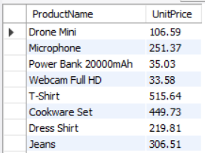

#3. Find all products with price greater than 500.
SELECT ProductName, UnitPrice FROM amazon
WHERE UnitPrice > 500;
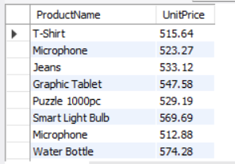

#4. List products where category is 'Electronics'.
SELECT ProductName, Category FROM amazon
WHERE Category = 'Electronic';
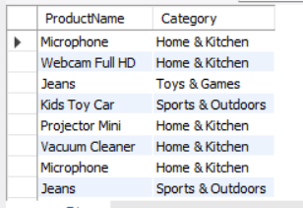

#5. Count total number of records in the dataset.
SELECT COUNT(*) FROM amazon;
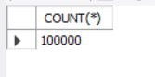

#6. Find the minimum product price.
SELECT MIN(UnitPrice) AS MIN_Price
FROM amazon;
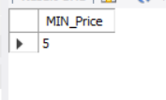
#7. Find the maximum product price.
SELECT MAX(UnitPrice) AS MAX_Price
FROM amazon;
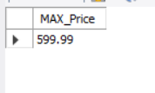
#8. Calculate the average product price.
SELECT AVG(UnitPrice) AS avg_price FROM amazon;
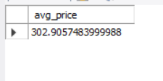
#9. Show all unique categories.
SELECT DISTINCT Category FROM amazon;
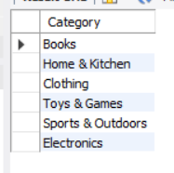

#10. Count how many products are in each category.
SELECT Category, COUNT(ProductName) AS total_product FROM amazon
GROUP BY Category;
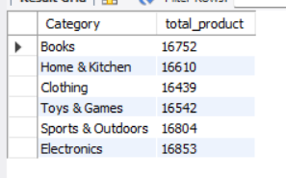

#11. List products sorted by price in ascending order.
SELECT ProductName, UnitPrice FROM amazon
ORDER BY ProductName ASC;
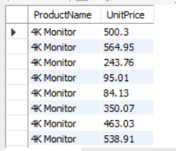

#12. List products sorted by price in descending order.
SELECT ProductName, UnitPrice FROM amazon
ORDER BY ProductName DESC;
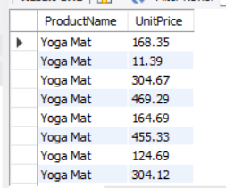

#13. Show top 10 most expensive products.
SELECT ProductName, UnitPrice
FROM amazon
ORDER BY UnitPrice DESC
LIMIT 10;
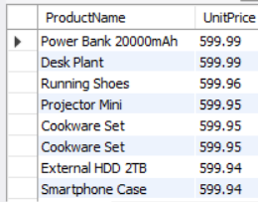

#14. Show 5 cheapest products.
SELECT ProductName, UnitPrice FROM amazon
ORDER BY UnitPrice ASC
LIMIT 5;
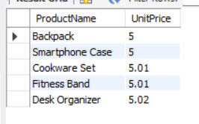

#15. Find products with rating greater than 4.

#16. Count how many products have rating less than 3.

#17. Display products where price is between 100 and 1000.
SELECT ProductName, UnitPrice FROM amazon
WHERE UnitPrice BETWEEN 100 AND 1000;
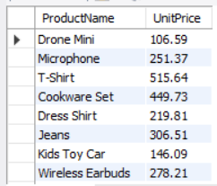

#18. Find products where category is either 'Electronics' or 'Clothing'.
SELECT ProductName, Category from amazon
WHERE Category IN ('Electronics','Clothing');
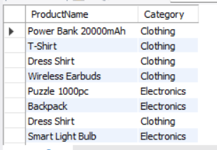

#19. Show products whose name starts with 'A'.
SELECT ProductName FROM amazon
WHERE ProductName LIKE 'A%';
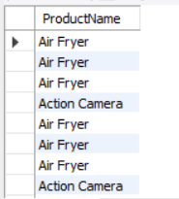

#20. Show products whose name ends with 's'.
SELECT ProductName FROM amazon
WHERE ProductName LIKE '%S';
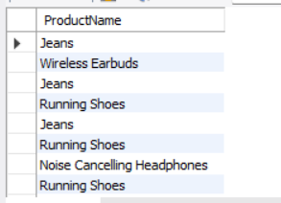

#21. Find products containing the word 'Phone'.
SELECT ProductName FROM amazon
WHERE ProductName LIKE '%Phone%';
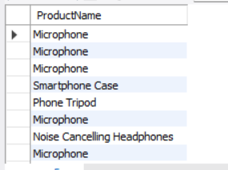

#22. Show average rating per category.

#23. Count number of products in each rating group.

#24. Find total number of reviews for each category.
SELECT Category, count(*) AS total_review FROM amazon
group by Category;
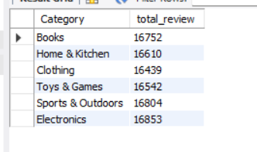

#25. Display category with highest average price.
SELECT category, AVG(UnitPrice) AS AVG_PRICE FROM amazon
GROUP BY category
ORDER BY category DESC;
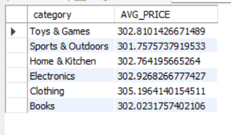

#26. Show category with lowest average rating.
SELECT category, AVG(UnitPrice) AS AVG_PRICE FROM amazon
GROUP BY category
ORDER BY category ASC;
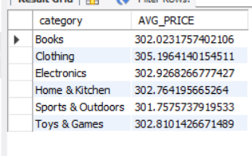

#27. Count number of products with discount applied.
SELECT count(*) AS discounted_products
FROM amazon
WHERE Discount > 0;
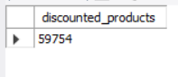

#28. Show products where discount is greater than 20%.
SELECT ProductName, Discount FROM amazon
WHERE Discount > 0.20;
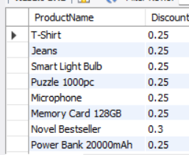

#29. Find average discount by category.
SELECT Category, AVG(Discount) FROM amazon
GROUP BY Category;
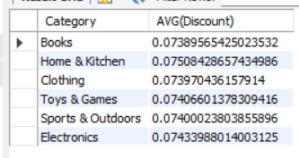

#30. Display products with NULL values in any column.
SELECT * FROM amazon
WHERE ProductName IS NULL;
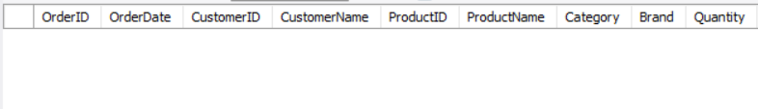
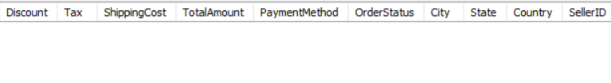

#31. Count how many records have NULL ratings.

#32. Replace NULL ratings with 0 and display results.

#33. Show products added after a specific date.
SELECT * FROM amazon
WHERE OrderDate > '2024-08-12';
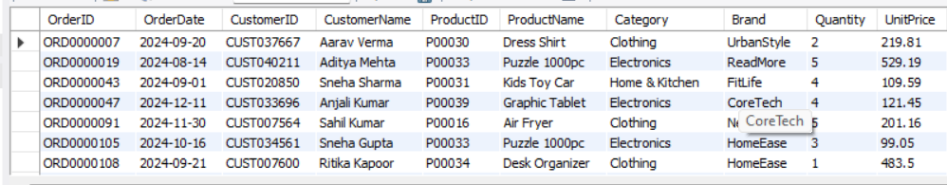
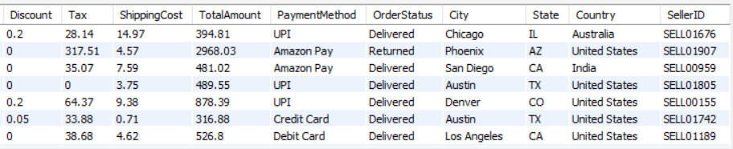

#34. Count number of products added each year.
SELECT YEAR(OrderDate) AS YEAR,COUNT(*) AS TOTAL_PRODUCT
FROM amazon
GROUP BY YEAR(OrderDate);
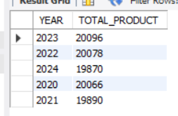

#35. Display month-wise product additions.
SELECT MONTH(OrderDate) AS month, count(*) AS total_product
FROM amazon
GROUP BY MONTH(OrderDate);
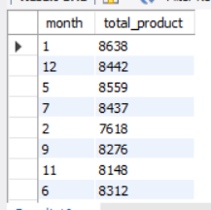

#36. Find the total revenue (price * quantity if available).
SELECT SUM(Quantity * UnitPrice) AS total_revenue FROM amazon;
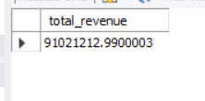

#37. Show top 5 categories by total revenue.
SELECT Category, SUM(Quantity * UnitPrice) AS total_revenue FROM amazon
GROUP BY Category
ORDER BY total_revenue DESC
LIMIT 5;
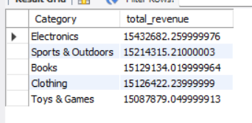

#38. Display products with highest number of reviews.
SELECT ProductName, COUNT(*) AS total_revies FROM amazon
GROUP BY ProductName
ORDER BY total_revies DESC
LIMIT 1;
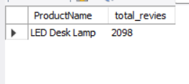
#39. Show products with lowest number of reviews.
SELECT ProductName, COUNT(*) AS total_revies FROM amazon
GROUP BY ProductName
ORDER BY total_revies ASC
LIMIT 1;
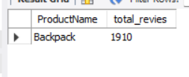

#40. Count number of products per brand.
SELECT COUNT(*), Brand FROM amazon
GROUP BY Brand;
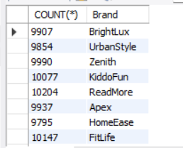

#41. Find most expensive product in each category.
SELECT ProductName, Category AS EXP_PRODUCT, UnitPrice FROM amazon
ORDER BY EXP_PRODUCT DESC
LIMIT 1;
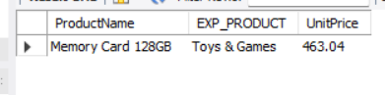
#42. Find cheapest product in each category.
SELECT ProductName, Category AS CHPST_PRODUCT, UnitPrice FROM amazon
ORDER BY CHPST_PRODUCT ASC
LIMIT 1;
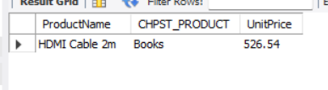

#43. Show average price for each brand.
SELECT AVG(UnitPrice), Brand FROM amazon
GROUP BY Brand;
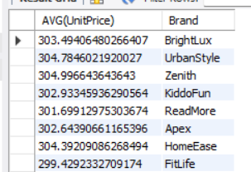

#44. List brands having more than 10 products.
SELECT COUNT(ProductName), Brand FROM amazon
GROUP BY Brand
HAVING COUNT(ProductName)> 10;
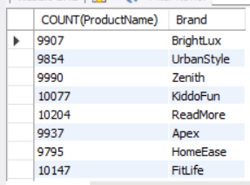

#45. Find categories having average rating above 4.

#46. Display products where price is above average price.
SELECT ProductName, AVG(UnitPrice) FROM amazon
GROUP BY ProductName;
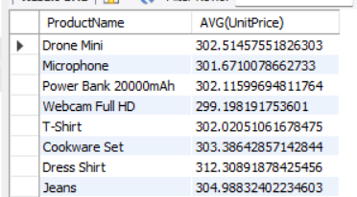

#47. Show products where rating is below average rating.

#48. Rank products based on price (highest to lowest).
SELECT ProductName, UnitPrice, RANK() OVER (ORDER BY UnitPrice DESC)
AS price_rank FROM amazon;
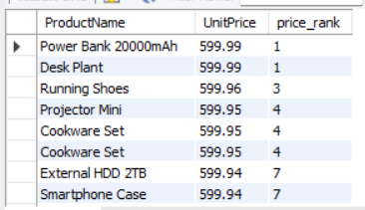

#49. Show cumulative count of products by category.
SELECT COUNT(ProductName), Category FROM amazon
GROUP BY Category;
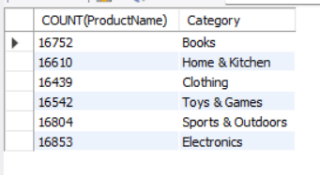

#50. Find duplicate product names if any.
SELECT DISTINCT ProductName FROM amazon;
